Associate Exit Flow

*(Associate Exit Flow – Guide)*

This document describes in detail the **Associate Exit Flow**. This portal has different user roles like (*Associate, Program Manager, HRM- Human Resource Manager, HRA, Team Lead, Manager-IT department, Manager-Admin department, Manager-Finance department, Manager-Training department).*

**Program Manager**

1. Once Associate submits the resignation. Email triggers to Program Manager. Status changes to “Resignation submitted by Associate”
2. The Program Manager needs to Login into the portal (Via single sign-on) with SenecaGlobal email Id. After authentication, the associate is redirected to the Dashboard page. The Program manager needs to click on the **Associate Exit** section and then an **Exit-Action module**.
3. System will display below screen

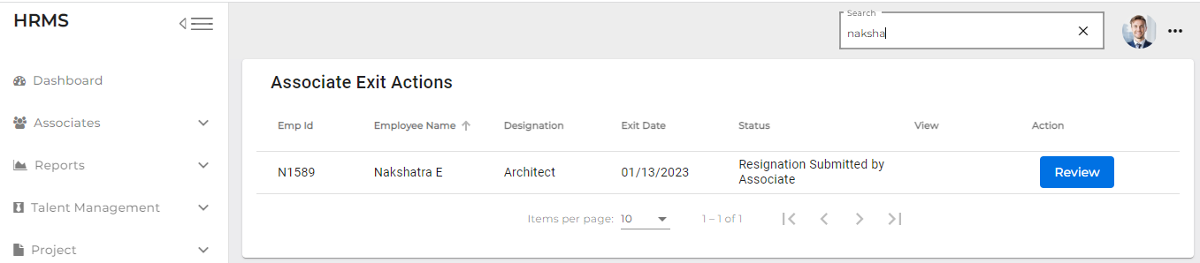

1. Status is shown as ‘Resignation Submitted’ by Associate. PM clicks on the Review button
2. System will display the below screen

1. By default, Client Impact and Eligible for Rehire radio buttons selected as "No" and PM can be able to change it.
2. Clicking on submit button confirmation pop-up message will display as "Are you

Sure, you want to confirm with yes/no buttons”

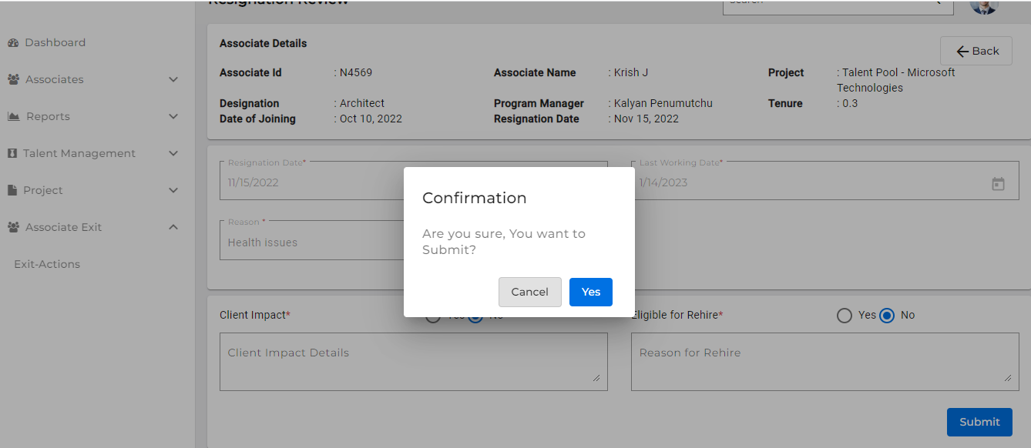

1. Click on Yes button, toast message will display as “submitted successfully”
2. After submitting the Resignation Review by PM, ‘Review’ button should be in disabled mode, able to view (eye icon), and status is changed to "**Resignation Reviewed by PM”**
3. **Email triggers to HRM, Associate, Program Manager and TeamLead,**